The Addams Family Musical
Graveyard Greetings!

Graveyard greetings are shout outs & well wishes that are printed in the show program. These are a nice way to recognize your performer or crew member with a personalized message from family or friends. Wishes are limited to 150 characters. The cost per greeting is $5.00. Greetings must be received AND paid for before Monday, April 1st. Payment for Graveyard Greetings can be cash or check(made out to Penn Middle School PTO). Send your form and payment in a sealed envelope with your Drama member to rehearsal and have them give them to the Director, Maddie or PMS Drama Sponsor, Sharon. Below are some examples of previous shout outs if you need inspiration.
GREETINGS CAN BE NO MORE THAN 150 CHARACTERS

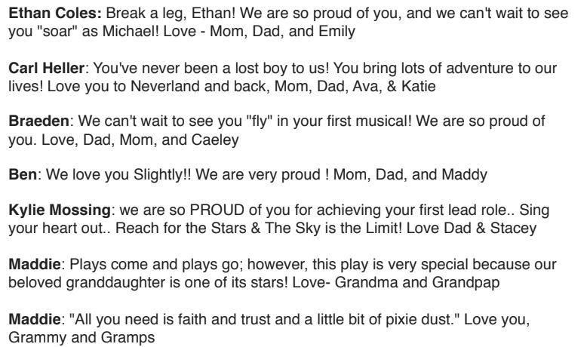

Performer Name: _________________________________________________

Graveyard Greeting: ____________________________________________________________
_______________________________________________________________________
_______________________________________________________________________
_______________________________________________________________________
_______________________________________________________________________
Performer Name: _________________________________________________

Graveyard Greeting: ____________________________________________________________
_______________________________________________________________________
_______________________________________________________________________
_______________________________________________________________________
_______________________________________________________________________

Please include $5.00 per 1 Greeting!
Cash or Check (Penn Middle School PTO)
If you would like more than 2 greetings, please feel free to write additional on the back of this sheet.

